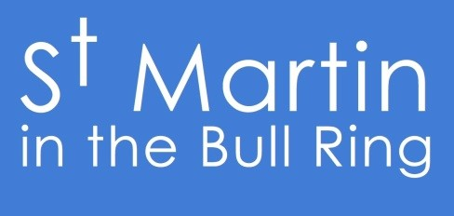
Special Christmas Services 2017

Sunday 3rd December
West Midlands Fire Service Carols 4.30pm
Sunday 10th December
Jazz Carols 4.30pm
Sunday 17th December
Christmas Carol Service 6pm
Christmas Eve
Holy Communion 9.30am
Morning Worship 11am
Candlelight Carols 5pm
Midnight Mass 11.15pm
Christmas Day
Family Communion 11am

Regular Services at St Martin’s Sundays 9.30am, 11am and 6pm, Tuesdays & Thursdays 12.30pm
(*See leaflet for special times of evening services in December)

For more information about St Martin’s and our special events:
www.bullring.org, email: admin@bullring.org, Tel: 0121 600 6020

